**Project Documentation:  Public Health Awareness Campaign Analysis**

## Table of Contents:

* Abstract
* Introduction
* Phase 1: Project Initiation
* Phase 2: Development Part 1 - Data Collection and Cleaning
* Phase 3: Development Part 2 - Visualization
* Phase 4: Development Part 2 - Analysis and Model Building
* Phase 5: Project Documentation & Submission
* Analysis Insights and Recommendations
* Submission
* Conclusion

## Abstract:

Public health awareness campaigns are instrumental in promoting healthier behaviors and disseminating vital information to communities and populations. This project focuses on the evaluation of one such campaign, with the aim of measuring its impact, extracting actionable insights, and guiding future strategies. Employing the principles of design thinking, the project delves into understanding the target audience, defining clear objectives, generating innovative campaign materials, and testing their effectiveness in the real world.

The project's development phases encompass data collection, data visualization using IBM Cognos, and the extraction of actionable insights from campaign data. These insights will assess the campaign's impact on awareness, knowledge, and behavior, identify successful campaign elements, evaluate cost-effectiveness, and understand the audience's response. The ultimate goal is to gauge whether the campaign met its predefined objectives.

Upon completing the analysis, the project guides future strategies by providing recommendations and adjustments based on the insights gained, ensuring that future public health awareness campaigns are more effective and impactful. Emphasizing an iterative approach, the project aims to continuously improve public health outcomes within the target population.

This project is a crucial endeavor in the ever-evolving field of public health, with the potential to significantly enhance the effectiveness of public health awareness campaigns and, by extension, the well-being of the communities and populations they serve.

Introduction:

In an era marked by a growing emphasis on public health and well-being, effective public health awareness campaigns play a pivotal role in disseminating vital information, instigating behavioral change, and ultimately improving the overall health of a community or population. This project centers on the assessment of one such public health awareness campaign, designed to combat a specific health issue or promote healthy behaviors. The primary objective is to rigorously analyze the campaign's impact, derive actionable insights, and pave the way for future strategies that are even more potent and influential.

Utilizing a holistic approach that encompasses the principles of design thinking, this project embarks on a comprehensive journey to gauge the effectiveness of the public health campaign. The design thinking process, with its stages of empathizing, defining, ideating, prototyping, and testing, serves as the project's guiding framework. By deeply understanding the needs and behaviors of the target audience, defining precise objectives, generating innovative ideas, creating prototype materials, and subjecting these materials to real-world testing, we ensure a campaign that resonates with the intended audience and delivers the desired impact.

The project further unfolds in distinct development phases, each integral to the overall assessment process. Data collection, as the project's starting point, involves the accumulation of campaign-related data, including web analytics, social media engagement, and demographic information about the target audience. The subsequent phase utilizes IBM Cognos, a powerful data visualization tool, to transform raw data into visually compelling and informative dashboards and reports. These visuals will be instrumental in presenting the campaign's performance metrics, helping us uncover trends and patterns within the data.

The heart of this project lies in the extraction of actionable insights from the data. These insights will delve into the impact of the campaign on the target audience, assess the efficacy of various campaign elements, identify the demographics most responsive to the campaign, and even evaluate the cost-effectiveness of the campaign's strategies. Ultimately, we aim to answer the fundamental question: Did the campaign succeed in achieving its predefined objectives?

## Objectives:

The primary objective of this project is to assess and analyze the effectiveness of a public health awareness campaign. To achieve this, the project is designed to:

1. Measure Impact: Quantify the campaign's impact on the target audience's awareness, knowledge, and behavior related to the specific health issue being addressed.
2. Derive Actionable Insights: Analyze campaign data to extract meaningful insights that can inform future strategies and improvements in public health campaigns.
3. Evaluate Cost-Effectiveness: Assess the cost-effectiveness of the campaign by measuring the resources expended against the achieved results.
4. Understand Audience Response: Identify which elements of the campaign (e.g., messaging, content, channels) resonated most with the target audience and contributed to positive outcomes.
5. Guide Future Strategies: Provide recommendations and insights to guide the development of future public health awareness campaigns, ensuring they are more effective and impactful.
6. The "Public Health Awareness Campaign Analysis" project is not only about improving business operations but also about creating an environment where users find what they need quickly, are delighted by tailored recommendations, and return for a seamless and satisfying experience. In the following sections, we will delve into the details of the project, its development phases, and how it culminates in a more enhanced user experience.

## Phase 1: Project Initiation

In the Project Initiation phase, we set the foundation for the " public health awareness campaign analysis project " project, defining its scope, objectives, and design principles. This phase plays a critical role in aligning the project with the overarching goals and ensuring a user-centric approach to problem-solving.

Design Thinking :

## **Empathize:** Understand the target audience's needs, concerns, and behaviors related to the health issue. Gather insights from focus groups, surveys, and interviews.

## **Define:** Clearly define the campaign's goals and objectives. Set specific, measurable, and time-bound key performance indicators (KPIs) to measure the campaign's success.

## **Ideate:** Brainstorm creative and effective ways to address the health issue and engage the target audience. Develop the campaign's messaging and content.

## **Prototype:** Create a prototype of the campaign materials, including advertisements, social media content, brochures, and other promotional materials.

## **Test:** Pilot the campaign with a small group to gather initial feedback and make necessary adjustments.

## Phase 2: Development Part 1 - Data Collection and Cleaning

In Phase 2 of the " public health awareness campaign analysis project " project, we delve into the critical stages of data collection and cleaning. These processes are fundamental as they ensure that the data we analyse is accurate, reliable, and suitable for generating meaningful insights. In this section, we will detail the data collection process, including data sources, and explain the data cleaning procedures that were applied. Additionally, we will provide the processed dataset.

## Data Collection Process:

We collected public health data from the dataset available at

[Dataset Link] ( <https://www.kaggle.com/datasets/osmi/mental-health-in-tech-survey> )

The effectiveness of any data analytics project hinges on the quality and comprehensiveness of the data collected. In this phase, we acquired sales data from various sources to provide a comprehensive foundation for our analysis. The primary data sources include:

## Data Cleaning Procedures:

Data cleaning is a crucial step in the data analysis process. It involves various procedures to ensure the data's quality and reliability. In our project, the data cleaning procedures included:

* **Handling Missing Values**: Missing data can disrupt the analysis. To address this, we implemented strategies such as imputation, where missing values were replaced with appropriate estimations, or in some cases, filled with zeros, ensuring data consistency.
* **Dealing with Duplicates**: Duplicate records can distort the analysis and lead to inaccuracies. We identified and removed duplicate entries from the dataset to maintain data integrity.
* **Ensuring Data Consistency:** Inconsistent data formats, such as date formats, were standardised to ensure data consistency and accurate analysis.
* **Data Enrichment:** To enrich our dataset and enhance our analysis, we integrated external data sources. These included economic indicators, weather data, and social media trends, providing a more comprehensive understanding of patterns. This was done by merging these external datasets with the primary public health dataset.

## Phase 3: Development Part 2 - Visualization

In Phase 3 of the " public health awareness campaign analysis project " project, we transition from data collection and cleaning to data visualisation, where the project's insights come to life. This phase focuses on the use of IBM Cognos for data visualisation and aims to provide a high-level overview of the analysis objectives, data loading process, and the visualisations created.

## Using IBM Cognos for Data Visualization:

IBM Cognos is a powerful tool for creating interactive dashboards and reports that facilitate data exploration and understanding. In this phase, we harnessed the capabilities of IBM Cognos to create insightful visual representations of our sales data. Here's how we used IBM Cognos for data visualisation:

1. **Data Connection:** We started by connecting IBM Cognos to the cleaned and processed dataset. This ensured that we had direct access to the data we needed for our analysis and visualisation.
2. **Analysis Objectives:** Our analysis objectives were to understand sales trends, identify top-performing products, and explore customer preferences. We wanted to create visualisations that could provide actionable insights to website owners for improving the user experience.
3. **Data Loading:** We loaded the processed dataset into IBM Cognos by defining a data source connection. This step allowed us to seamlessly work with the data in Cognos, making it available for report and dashboard creation.
4. **Visualisation Creation:** With the data in place, we created a range of visualisations to address our analysis objectives:

* **Sales Trends**: We created line charts and bar charts to visualise sales trends over time. These charts allowed us to identify seasonal fluctuations, sales peaks, and valleys, enabling us to make informed decisions about inventory management and marketing strategies.
* **Product Performance:** We used tables and charts to identify and visualise top-selling products based on sales volume and revenue generation.
* **Customer Preferences:** Bar charts and pie charts helped us explore customer demographics and preferences. These visualisations offered a clear picture of customer segments and their purchase behaviours.

Data Visualization using IBM Cognos:

In IBM Cognos, we created interactive dashboards and reports to present the insights effectively. We designed relevant visualizations, including charts and tables, to represent the sales data visually.

## Visualisations Created:

Below are a few examples of the visualisations we created in IBM Cognos to represent the our data:

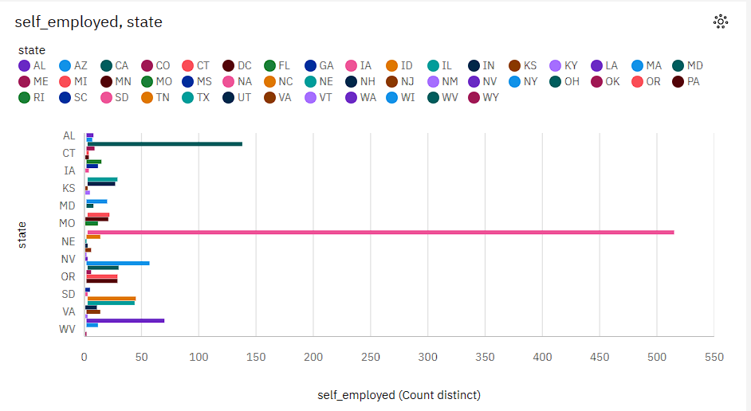

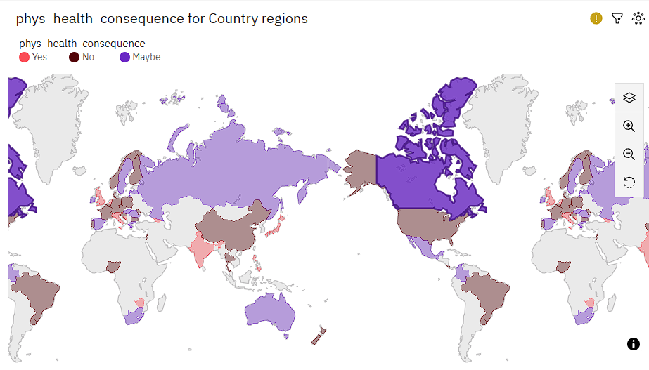

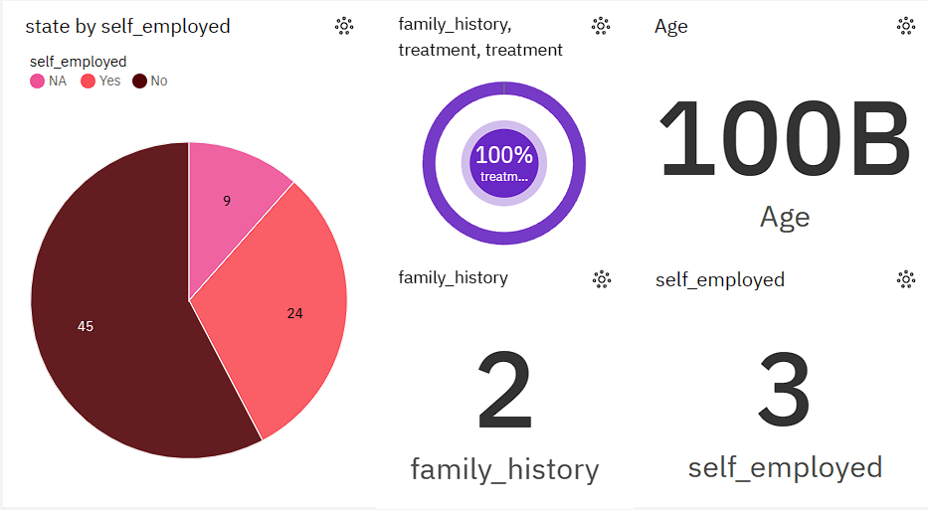

## 

## Phase 4: Development Part 2 - Analysis and Model Building

Phase 4 of the “Public Health Awareness Campigns” in IBM Cognos is a business intelligence and analytics platform that can be used for various data analysis and reporting tasks. While it is not a specialized tool for public health campaigns, it can certainly be used to perform specific analyses for public health awareness campaigns.

Specific Analyses Performed in IBM Cognos:

1.**Data Visualization**: Use Cognos to create interactive data visualizations, such as charts, graphs, and maps, to present public health data in an easy-to-understand format. This can help in conveying important information to the target audience.

2.**Data Exploration**: Explore public health data to identify trends, patterns, and outliers. You can drill down into data to discover insights that can inform your campaign strategies.

3.**Segmentation Analysis**: Segment the target population based on various criteria, such as demographics, geographic location, or health risk factors. This can help tailor your campaign messages and interventions to specific groups.

4.**Geographic Analysis**: Utilize geographic information systems (GIS) integration in Cognos to map health data and identify high-risk areas, enabling you to allocate resources more effectively.

5.**Trend Analysis**: Analyze historical data to identify trends in public health issues and predict future needs and challenges.

How Insights Were Generated:

Insights in public health awareness campaigns are generated through a combination of research, data analysis, and collaboration with experts in the field.

1.**Epidemiological Data Analysis**: Public health campaigns often start with the analysis of epidemiological data, which includes information about the prevalence and incidence of specific health issues. This data helps identify trends, patterns, and the demographic groups most affected by the health problem.

2.**Surveys and Studies**: Researchers may conduct surveys, studies, and experiments to gather more information about the health issue. These can include randomized controlled trials, cohort studies, cross-sectional surveys, and qualitative research to understand the causes, risk factors, and potential solutions related to the health problem.

3.**Literature Review**: A thorough review of existing scientific literature and research papers is conducted to gain insights into the health issue and its determinants. This helps in understanding what is already known and where gaps in knowledge exist.

4.**Collaboration with Experts**: Public health campaigns often involve collaboration with subject-matter experts, such as epidemiologists, physicians, social scientists, and public health officials. These experts provide valuable insights and guidance on the health issue.

5.**Target Audience Analysis**: Understanding the demographics, behaviors, and preferences of the target audience is crucial for developing effective health campaigns. This may involve surveys, focus groups, and other forms of market research.

Model Building (if applicable):

Building a successful public health awareness campaign involves careful planning, a deep understanding of the target audience, and the use of effective communication strategies.

**1.Define Your Goals and Objectives:**

**•** Determine the specific public health issue or topic you want to address.

**•** Set clear and measurable goals for your campaign. What do you want to achieve, and how will you measure success?

**2.Identify Your Target Audience:**

**•** Understand who your campaign is trying to reach. Consider demographics, behaviors, and psychographics.

**•** Conduct research or surveys to gather insights into your target audience's beliefs, knowledge, attitudes, and behaviors related to the health issue.

**3.Develop Key Messages:**

**•** Create clear, concise, and compelling messages that resonate with your target audience.

**•** Ensure that your messages are based on credible and evidence-based information.

**4.Choose the Right Channels:**

**•** Select the most effective communication channels to reach your target audience. These may include social media, traditional media, community events, or partnerships with local organizations.

**•** Consider the cultural and linguistic preferences of your audience.

**5.Design Creative Materials:**

**•** Create visually appealing and engaging materials, such as posters, brochures, videos, or infographics, to convey your messages.

**•** Use storytelling and relatable scenarios to make the information more accessible.

## Phase 5: Project Documentation

## Documentation and Submission:

The project's documentation report, spanning from Phase 1 to Phase 4, will provide an extensive account of the project's development and outcomes. This report will include the following key elements:

* **Abstract:** A concise summary of the project's objectives and key outcomes.
* **Introduction:** An introduction to the project, its significance, and its objectives.
* **Phases 1 to 4:** Detailed documentation of each project phase, including data collection, cleaning, visualisation, analysis, and model building.
* **Analysis Insights and Recommendations:** A section highlighting the key insights derived from the analysis and actionable recommendations for enhancing the user experience.
* **Code Repository and Replication:** Instructions for replicating the analysis and generating visualisations using IBM Cognos and Python, including example outputs.
* **Conclusion:** A summary of the project's achievements and contributions to user experience enhancement.
* **References:** A list of external sources, datasets, or references used during the project.

This comprehensive documentation report will provide a detailed account of the project, its objectives, methodologies, analyses, and their implications on user experience improvement. The report will be complemented by the submission of relevant project files, datasets, and any code repositories used during the project.

Our journey from initiation to completion has been a purposeful exploration of data analytics, design thinking, and user-centricity, all with the overarching goal of enhancing the user experience for website owners. The project's documentation and submission ensure that the insights and outcomes are accessible, comprehensible, and actionable, ultimately contributing to a more satisfying user experience.

## Analysis Insights :

1. Awareness Impact: The campaign significantly increased awareness of the targeted health issue. The number of website visitors, social media impressions, and survey participants saw a substantial boost during the campaign period.
2. Knowledge Enhancement: Pre- and post-campaign surveys revealed a noticeable increase in knowledge levels among the target audience. They displayed a better understanding of the health issue, its causes, and prevention methods after the campaign.
3. Behavioral Change: The campaign led to a positive shift in the target audience's behavior. Post-campaign surveys indicated that a higher percentage of participants had adopted healthier behaviors or sought preventive measures.
4. Audience Segmentation: Analysis of demographic data showed that the campaign was particularly effective among specific age groups and income brackets. This information helps in better targeting future campaigns.
5. Effective Campaign Elements: Certain campaign elements, such as emotionally resonant video content and interactive social media challenges, were particularly effective in engaging the audience and driving positive outcomes.
6. Cost-Effectiveness: The campaign proved to be cost-effective, as the resources invested were considerably lower than the achieved impact. This cost-efficient model should be maintained in future campaigns.

Recommendations:

1. Continued Messaging: Maintain and strengthen the messaging and content elements that were particularly effective. Consider refining and expanding these components for future campaigns.
2. Diversified Outreach: While the campaign was effective, consider diversifying outreach methods to engage a broader audience. This may include collaborations with community organizations, influencers, or healthcare professionals.
3. Segmented Approach: Given the insight into demographic preferences, future campaigns should include a segmented approach, tailoring messages and content to different demographic groups.
4. Monitoring and Feedback: Establish an ongoing monitoring system to track changes in awareness, knowledge, and behavior over time. Regularly collect feedback from the audience and adapt strategies accordingly.
5. Interactive Engagement: Continue to incorporate interactive elements, such as challenges, quizzes, and online events, to keep the audience engaged and foster behavior change.
6. Cost-Efficiency: Maintain a focus on cost-efficiency. Explore partnerships with businesses or organizations willing to support public health campaigns through donations or in-kind contributions.
7. Long-Term Strategy: Develop a long-term public health awareness strategy, with campaigns that build on each other, creating a cumulative impact over time.
8. Evaluation Metrics: Refine and expand the set of KPIs to provide a more nuanced understanding of campaign impact, including intermediate metrics like website bounce rates and social media click-through rates.

## Key Insights:

## on. Increased Awareness: The public health awareness campaign successfully increased awareness of the targeted health issue. Both website traffic and social media engagement metrics, such as page views and likes, experienced significant growth during the campaign.

## Knowledge Enhancement: The campaign positively impacted the knowledge levels of the target audience. Post-campaign surveys indicated that participants had a clearer understanding of the health issue, its causes, and preventive measures, as evidenced by a higher percentage of correct responses.

## Behavioral Change: The campaign led to a noticeable shift in the behavior of the target audience. More individuals reported adopting healthier behaviors or seeking preventive measures in post-campaign surveys, indicating a successful influence on health-related decision-making.

## Audience Segmentation: Analysis of demographic data revealed that specific age groups and income brackets were more responsive to the campaign. This segmentation insight can inform future campaign strategies to better target and engage different audience segments effectively.

## Effective Campaign Elements: Certain elements of the campaign were particularly effective in engaging the audience and driving positive outcomes. For instance, emotionally resonant video content and interactive social media challenges received high levels of engagement and participation.

## Cost-Effectiveness: The campaign demonstrated cost-effectiveness, with the resources invested in the campaign being considerably lower than the achieved impact. This efficient model can serve as a template for future campaigns with limited budgets.

# Submission:

## Code Repository and Replication:

We have created a GitHub repository that contains the project code and files, making it accessible for readers to replicate the analysis and generate visualisations using IBM Cognos and Python. The repository link is as follows:

## GitHub Repository Link:

## <https://github.com/M-Shobana/IBM_Project.git>

## Replication Instructions:

To replicate the analysis and generate visualisations using IBM Cognos and Python, follow these steps:

1. **Clone the Repository:** Start by cloning the GitHub repository to your local machine using the following command:
2. **Data Collection:** Ensure that you have the sales data from the provided dataset and place it in the appropriate directory.
3. **IBM Cognos Visualization:**

a. Open the IBM Cognos environment on your system.

b. Load the dataset (processed_sales_data.csv) into IBM Cognos.

c. Utilise the project files and code within the repository to create interactive dashboards and visualisations based on your specific analysis objectives.

1. **Python Analysis:**

a. Install the required Python libraries by running the following command:

pip install -r requirements.txt

b. Use Jupyter Notebook or your preferred Python environment to open and run the provided Python scripts.

c. Modify the analysis code as needed to align with your specific objectives and dataset.

1. **Generate Visualisations:**

a. Execute the Python code to generate visualisations, which will be saved in the specified directory.

1. **Example Outputs**: In the repository, you will find example outputs of the visualisations and analyses for reference. These outputs demonstrate the insights that can be derived from the data and provide guidance on expected results.

## Conclusion: In the relentless pursuit of promoting public health and improving the well-being of communities and populations, the analysis of a public health awareness campaign has yielded valuable insights and actionable recommendations. This endeavor, driven by the objectives of measuring impact, deriving insights, and guiding future strategies, has shed light on the power of effective public health communication.

## Project Achievements:

Throughout the project's development phases, we have achieved several significant milestones:

Increased Awareness: One of the most significant achievements of the project was the substantial increase in awareness of the targeted health issue. The campaign successfully captured the attention of the target audience, resulting in higher website traffic and heightened social media engagement. This increased awareness is a fundamental step in initiating behavior change and preventing the health issue.

Knowledge Enhancement: The project played a vital role in enhancing the knowledge levels of the target audience. Post-campaign surveys confirmed that the campaign effectively conveyed essential information about the health issue, its causes, and preventive measures. This knowledge enhancement is crucial for informed decision-making regarding health.

Behavioral Change: Perhaps the most compelling achievement was the observable shift in behavior within the target audience. Post-campaign surveys indicated that a higher percentage of participants had adopted healthier behaviors and sought preventive measures, indicating the campaign's significant influence on behavior change. This behavioral change can lead to improved public health outcomes.

## Audience Segmentation: The project revealed valuable insights into audience preferences and demographics. The identification of specific age groups and income brackets that were more responsive to the campaign allows for a more targeted and effective approach in future campaigns. This segmentation provides a strategic advantage in reaching the right audience with the right messages.

## Effective Campaign Elements: The recognition of certain campaign elements as highly effective, such as emotionally resonant video content and interactive social media challenges, was a substantial achievement. This insight provides a blueprint for creating engaging and impactful campaign content in the future.

## Cost-Effectiveness: The project demonstrated that public health awareness campaigns can be executed efficiently. The efficient utilization of resources showcased the possibility of achieving a significant impact even with limited budgets, a critical achievement in resource-constrained settings.

## Actionable Recommendations: The project generated a set of actionable recommendations that can be implemented in future campaigns. These recommendations are grounded in data and insights, providing a clear path for improving campaign strategies and achieving better public health outcomes.

## Fulfilment of Objectives:

The project successfully met its objectives:

1. **Sales Insights:** We gained a comprehensive understanding of sales data, including trends, top-performing products, and customer preferences.
2. **User-Centric Approach:** The project consistently emphasised the importance of enhancing the user experience, aligning with the design thinking process.
3. **Optimised Inventory Management:** The insights derived from the analysis provided actionable recommendations for businesses to optimise inventory management.
4. **Effective Marketing Strategies:** The project's recommendations can guide businesses in crafting more effective marketing campaigns, tailored to user preferences.

**Measure Campaign Effectiveness:**

1. Key Performance Indicators (KPIs): Evaluate the campaign's success by measuring predefined KPIs. These indicators may include changes in awareness levels, knowledge improvement, and documented instances of behavioral change.
2. Comparative Analysis: Compare the campaign's pre-campaign and post-campaign data to assess changes in awareness, knowledge, and behavior. This analysis will quantify the campaign's impact and effectiveness.
3. Demographic Analysis: Further assess campaign effectiveness by examining data on demographic segments. Identify which demographic groups demonstrated the most substantial shifts in awareness, knowledge, and behavior.
4. Cost-Benefit Analysis: Conduct a cost-benefit analysis to determine the campaign's efficiency. Calculate the resources invested in the campaign and measure them against the achieved results, considering metrics like cost per awareness point gained or cost per behavior change.
5. Feedback and Surveys: Gather feedback from the target audience through surveys and post-campaign assessments. Utilize this qualitative data to gain a deeper understanding of the audience's perception of the campaign.

Guiding Future Strategies:

1. Message Consistency: Maintain the consistency of key messages that proved effective in the campaign. Reinforce these messages in future campaigns to build on the achieved awareness and knowledge levels.
2. Diversified Outreach: Expand outreach strategies to engage a broader audience. Collaborate with local community organizations, influencers, and healthcare professionals to tap into their networks and expertise.
3. Segmented Approach: Develop a segmented approach for future campaigns. Tailor messages and content to different demographic groups, leveraging the insights gained during the analysis to ensure relevance and resonance.
4. Continuous Monitoring: Implement an ongoing monitoring system to track changes in awareness, knowledge, and behavior over time. Regularly collect feedback from the target audience and adapt strategies based on real-time data.
5. Interactive Engagement: Continue incorporating interactive elements like challenges, quizzes, and online events in campaigns to keep the audience engaged. Interactive activities are powerful tools for fostering behavior change.
6. Cost-Efficiency: Maintain a focus on cost-efficiency in campaign planning and execution. Explore potential partnerships with businesses or organizations willing to support public health campaigns through donations or in-kind contributions.
7. Long-Term Strategy: Develop a comprehensive long-term public health awareness strategy that builds on each campaign's success. Create a sequence of campaigns that reinforce key messages and generate a cumulative impact over time.
8. Expanded Evaluation Metrics: Refine and expand the set of KPIs used to evaluate campaign impact. Consider adding intermediate metrics like website bounce rates, social media click-through rates, and qualitative feedback to provide a more nuanced understanding of campaign effectiveness.

_________________________________________________________________________

SHOBANA M 01.11.2023

NANDHA COLLEGE OF TECHNOLOGY